TRC RAMALLAH
PROPOSAL FOR THE THREE DAYS PSYCHODRAMA WORKSHOP
IAGP EDUCATIONAL PROJECT
(From 8th, 9th and 10th of MAY 2023)

Dr. URSULA HAUSER and Dr. MAJA HESS

1st day, 8th of May: 9am – 3pm
This year it is a women’s group: 10 participants
- SOCIOMETRY:
Creating this group and refreshing the knowledge about this important part of J.L. MORENO´s Methodology.
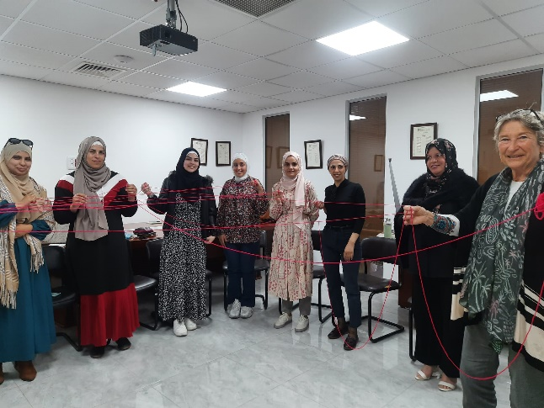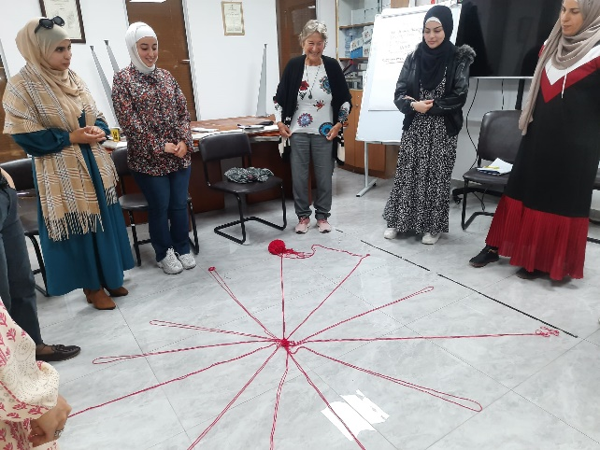
- SOCIOGRAM: The historic structure of the group, and the curiosity: Whom I want to know (better)? Who was participating last year?
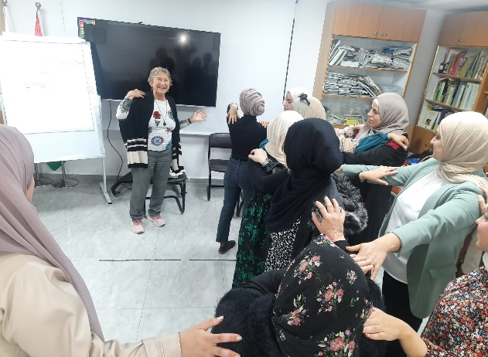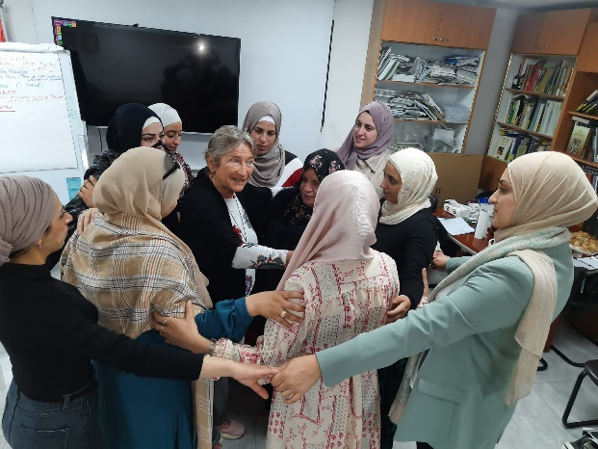

GOOD WISHES FOR THE MOTHER AND THE BABY:
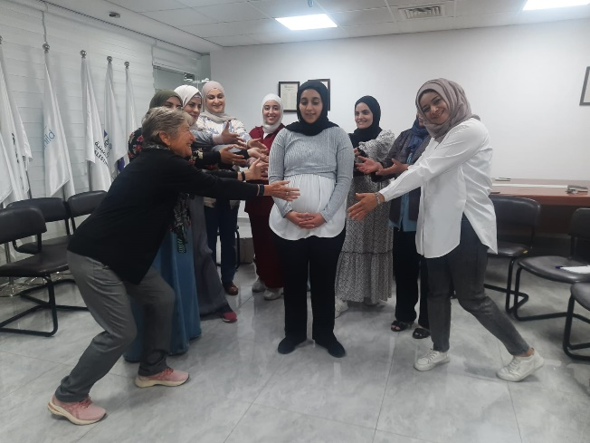

- INTRODUCTION OF PSYCHODRAMA (the empty chair)
Working on Theory, Techniques and Philosophy of Psychodrama; for some participants this will be new, for others the possibility of active co-coordination.
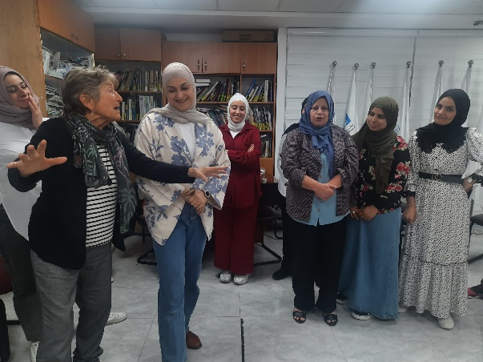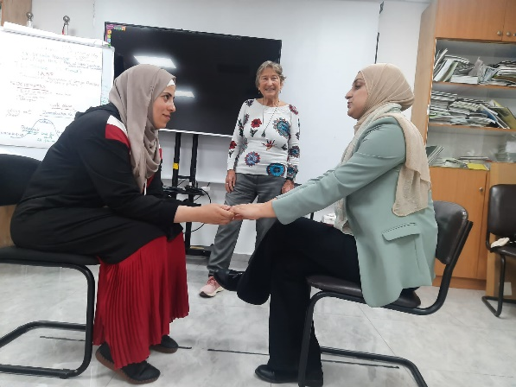
- PSYCHODRAMA: Free choice of a Theme and GROUP ELECTION of the Protagonist
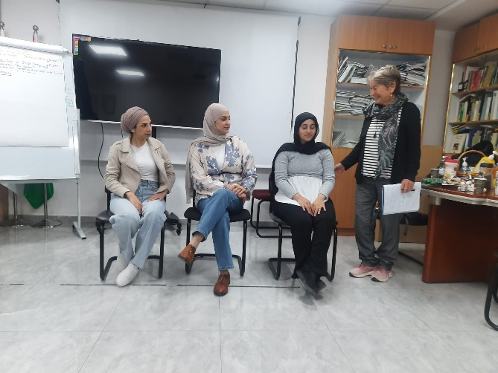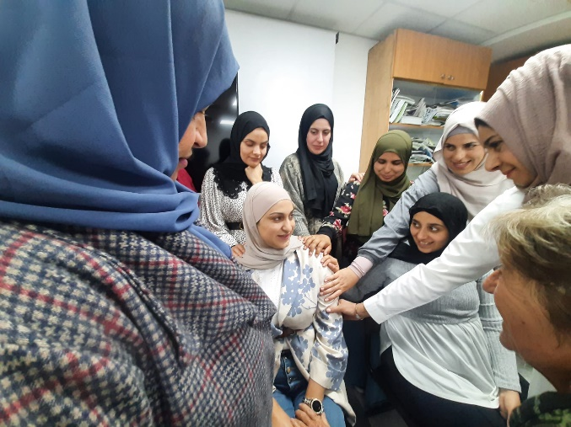
Process of Psychodrama, Sharing, Analyses of the Psychodrama
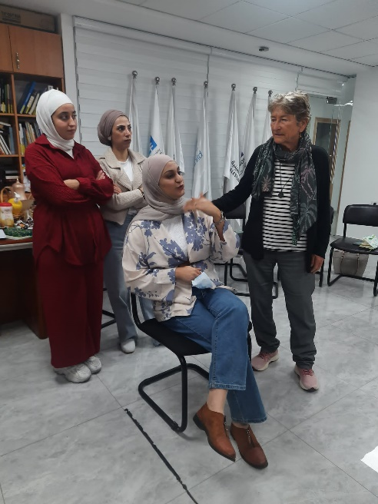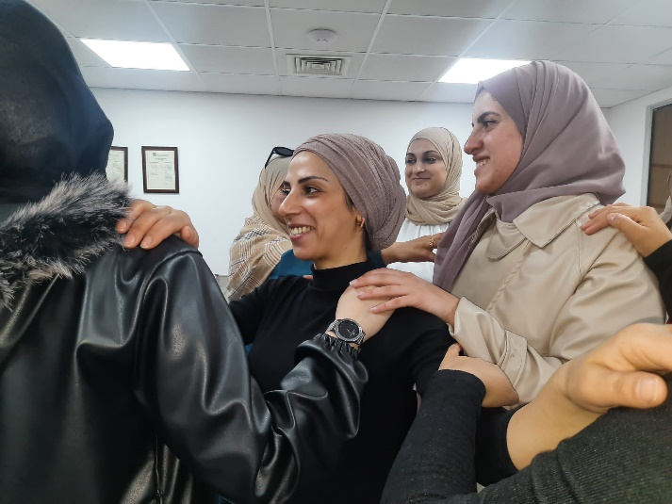
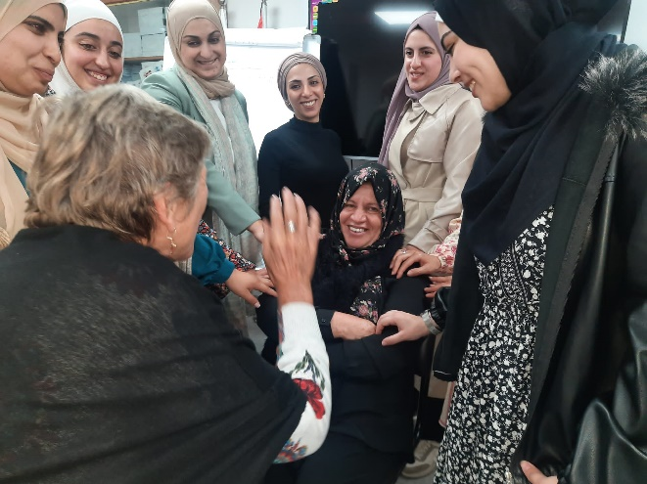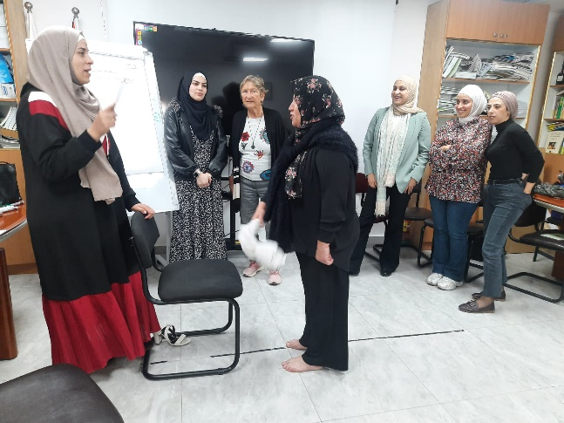
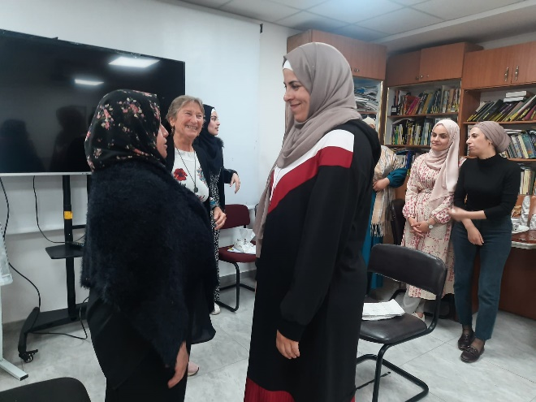
The Analyses of the processes was very intense and interesting, all participants eagerly want to know more about PSYCHODRAMA and are interested in a long-term training.
We talk about it with KHADER and MAHMOUD SEHWAIL, and on zoom with Maurizio!
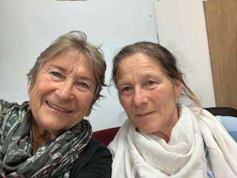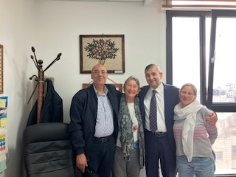
2nd day, 9th of May: 9am – 4pm: WARMING UP (Maja)
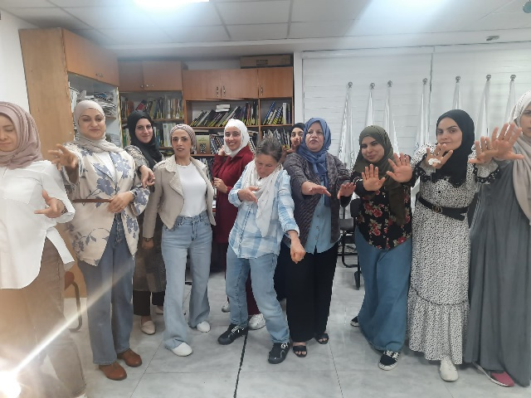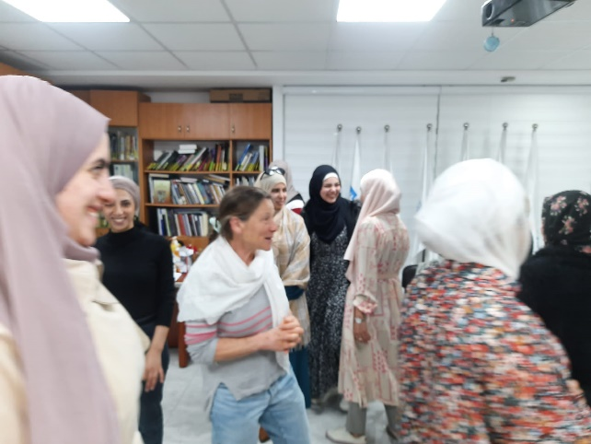
PROCESS ANALYSES
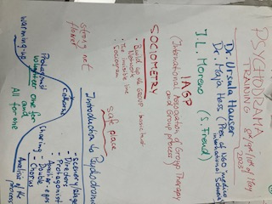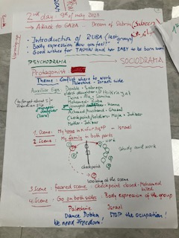

3rd day, 10th of May: 9am – 4pm
GAZA IS UNDER BOMBING !

- WARMING UP
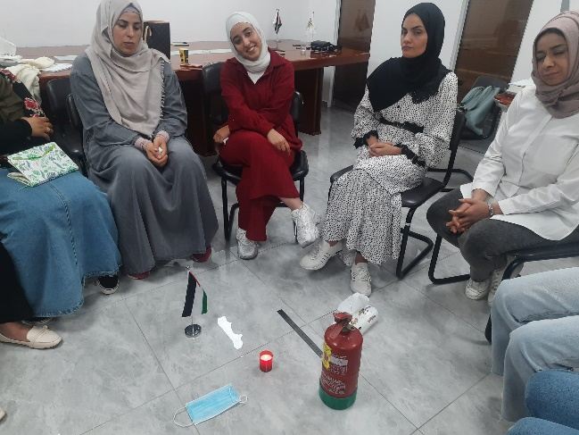

- OUR DREAMS OF THESE DAYS: PLAYBACK THEATER

- DRAMATIZING with PROTAGONISTS THE DREAMS

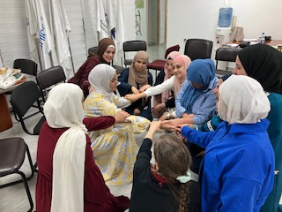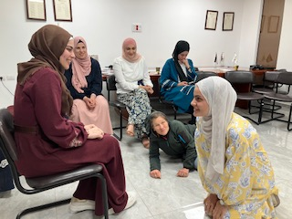
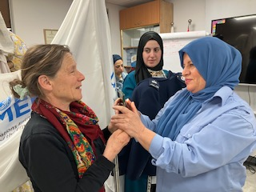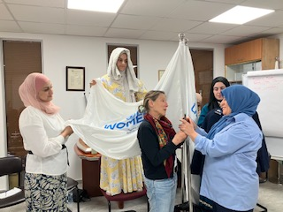
- SHARING
- PROCESS ANALYSES OF THE WORKSHOP AND THEORY
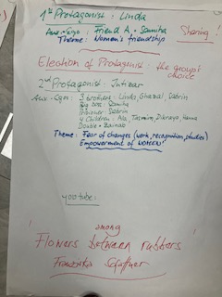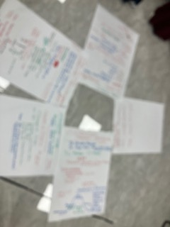
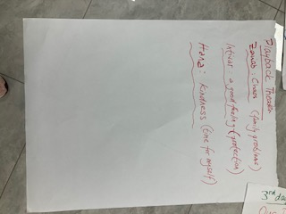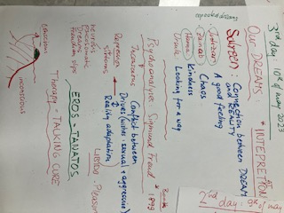

- CLOSING SESSIÓN
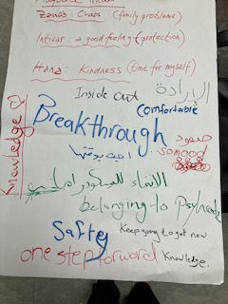 A COLLECTIVE SUCCESS, WITH DEEP SADNESS AND ANGER FOR THE NEW ATTACK OVER GAZA!
WORKSHOP WITH five MEMBERS OF THE BOARD, 8th of May, 4pm – 6.30pm
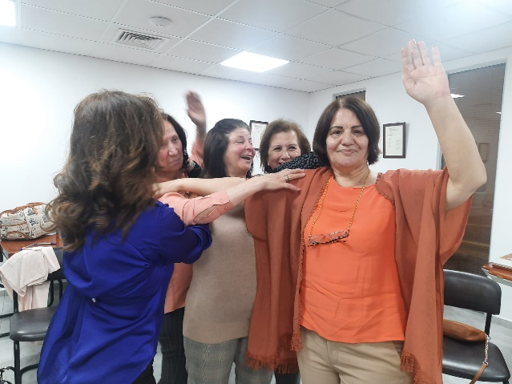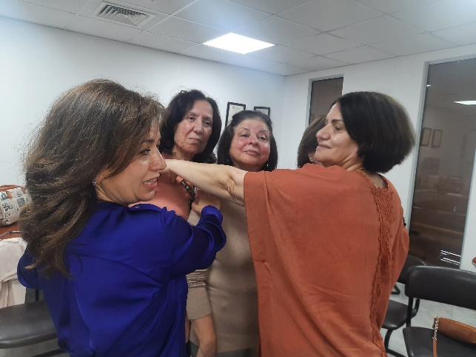
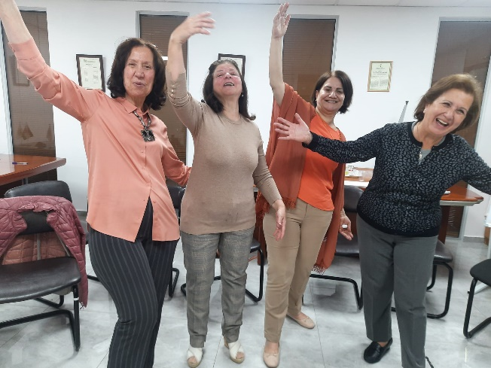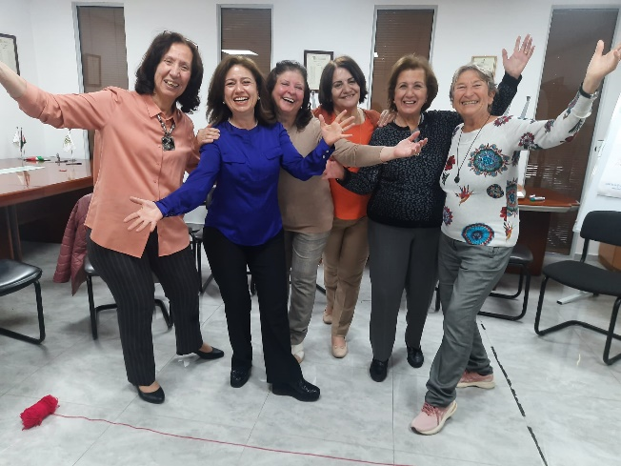

SUPERVISION WORKSHOP WITH THE SENIOURS, 9th of May, 4pm-6.30pm
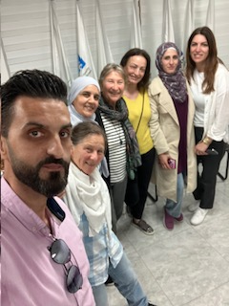
FIELD WORK WITH TRC PSYCHOLOGISTS: 13th of May, 8.30am–2pm
As we could not enter Gaza as we planned on 11th of May, we accompanied the colleagues from TRC to the village of BEIT REEMA, where almost every family lost a son/husband/father, lately 2 young brothers, killed by Israeli settlers. Many of the men of this village have been – or are actually -prisoners in the Israeli prisons, mostly without any legal accusation. The women we meet suffer from depression, but are very strong and conscientious of the political situation. Some of them travel a daylong way in order to visit their family member, and many times are rejected or only allowed to see the prisoner a moment. A cruel and illegal violence continuous without any legal accusation and remains impugned, meanwhile the families live with anxiety and suffer from psychological stress and many symptoms, surrounded by the armed settlers.
We admire the work of our colleagues and the strength of resistance in these women, who actually cannot see any future for their sons and daughters, and are afraid themselves to lose their houses and the small pieces of land which is still left.
Sad and furious we leave this village and think of the words of a friend from Gaza: WE KEEP OUR DREAMS, BUT HOPE IS FAR AWAY!
